Foxbright Teacher Training

Overview
- Introduction to our new website teacher pages
- Logging in
- My pages preview
- What am I editing?
- Contact information
- Weebly or Planbook or Foxbright or…. ?
- Teacher page content
- Adding & editing pages

Log in
- Go to ELPS.us > Staff Links > Foxbright Teacher Pages
- Enter your East Lansing username and password & click Login or press enter

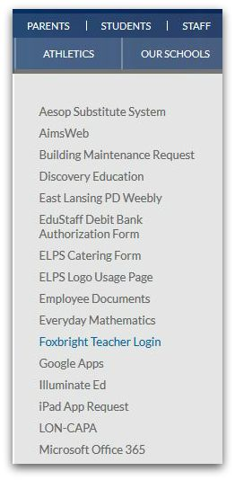

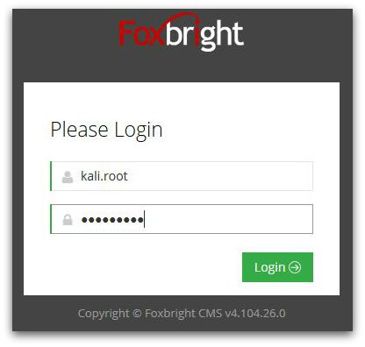

Edit Contact Information
- To change contact information listed on the profile page click on the My Information drop-down in the upper-right corner where your name is displayed
- Update password, contact information in staff directory/on your profile page, add profile photo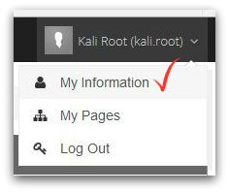

Your Teacher Page
- Click on the My Pages link at the top

Preview
- Click Preview in the upper-right corner of your page to preview what your page will look like to the public
- If you have issues with Preview, make sure pop-up blockers are disabled (pop-up blockers can prevent your Preview from appearing)
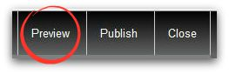

Edit pages (add or edit content after creating a new page)
- Click on the My Pages link at the top
- Edit your pages by clicking the page name under My Pages
- When you open a page, you will see content blocks – these are what you will edit
- To edit these blocks, hover over the block and click edit
- Use the predefined styles to edit your block (similar to the toolbar in Word)
- Click Save when done

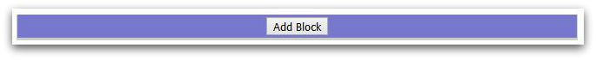

Change content block
- You can change content blocks to things such as photo galleries, calendars, expandable sections and more

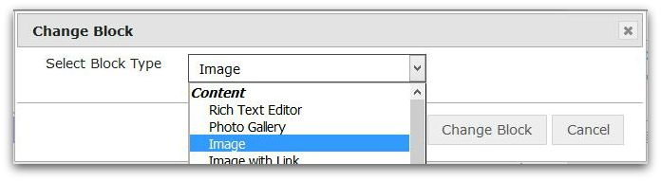

Paste from Word
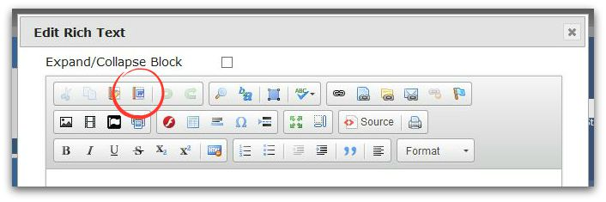
- There is a specific paste from Word option that allows you to copy/paste in from Word without losing your formatting

Add a new page
- Click on the My Pages link at the top
- Click on the settings gear next to your main profile page and select add page to add a new page to your site
- Type the name of your page
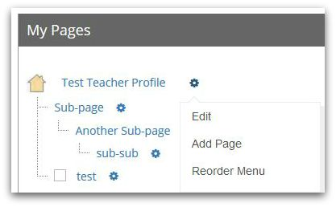
- Click save

To rename page
- Click the settings gear next to the page name and select Settings to rename the page
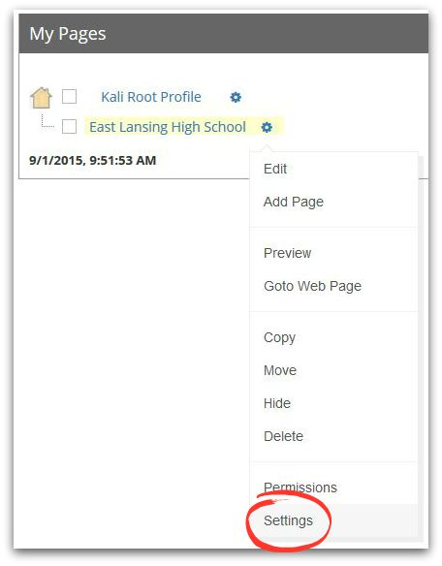
- Can rename all pages but profile page

To link to pages outside your teacher page
- In the Rich Text Editor, title your link (ex. Click here to visit our classroom website!)
- Open your website & copy the URL
- Highlight your text
- Select the link icon in the toolbar
- Paste the URL into the space provided and click OK
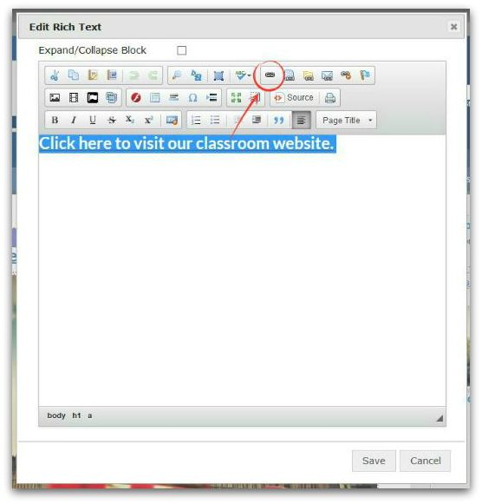
- Select Save

To add a calendar
- Step 1
  - Select the Calendar tab on the left-hand side of your Home screen
  - Select Add Calendar
  - Name your Calendar
    - IMPORTANT: be sure to include YOUR name in the title. This is important for when you select to add the Calendar to your teacher page
  - Select Save
- Step 2
  - Go to your teacher page
  - Add a block
  - Select Mini Calendar
  - Select the your calendar from the available list

To add a calendar event/assignment
- Select the Calendar tab on the left-hand side of your Home screen
- Select Add Calendar Event
- Enter event/assignment information
- Select Save (event automatically shows on your teacher page calendar)

To add images and files
- Step 1 – for both images and files
  - Select the Images/Files tab on the left-hand side of your Home screen
  - Select Bulk Add Files
  - In Category drop-down select My Files
  - Select + Add files
  - Select images & files from your PC
  - Select Start Upload
- Step 2 – for images
  - Go to your teacher page
  - Add an Image block
  - Select Change to add image
  - Select image (added in Step 1)
  - Select Save
- Step 2 – for files
  - Go to your teacher page
  - Add a Rich Text Editor block
  - Select the Link to file icon in the toolbar
  - Select Save

To hide a page
- Click the settings gear next to the page you would like to hide
- Select Hide
- Click Publish Selected to publish your change
- Once your publish your change, the page will be hidden from the public

To un-hide a page
- Click the settings gear next to the page you would like to hide
- Select Show
- Click Publish Selected to publish your change
- Once your publish your change, the page will reappear to the public

Publish
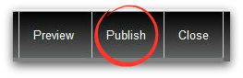
- If everything looks good after editing and previewing your page, click Publish (this makes your changes visible to the public)

How do I get back to my teacher page?
- Go to ELPS.us > Staff Links > Foxbright Teacher Pages
- Enter your East Lansing username and password & click Login or press enter

More help
- For more help on creating and editing teacher pages, go to www.eastlansingPD.weebly .com > PD Topics > Foxbright
- You may also visit support.foxbright.com

